|  |
| --- |
| Circle Language Spec: Commands |

## Procedure in a Diagram

The term *procedure* is already defined in the article *Procedure*. The current article only shows the concept in a diagram.

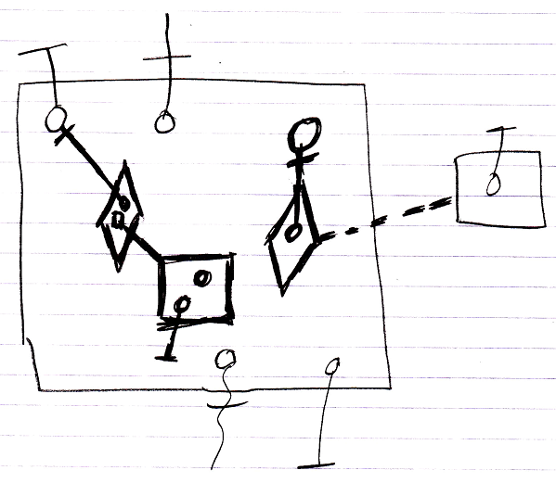

The contents of the large square, drawn with thick lines, are the command’s *procedure*, because they are all private contents The objects contained inside the large square, that are drawn with normal lines, are the command’s parameters.